**SHEET -7 – ACCESS CONTROL LISTS**

1. Create a directory named TestaclDir under your home directory with 755 permissions

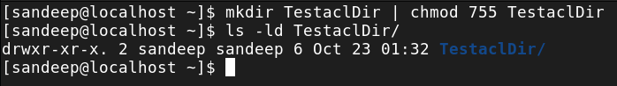

1. Create a file named TestaclFile under your home directory

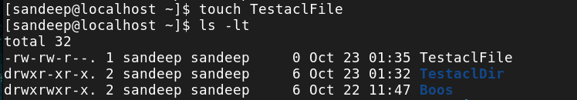

1. Observe the permissions of dir and file created (ls -l /ls -ld)

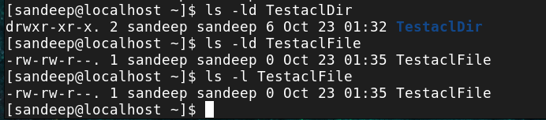

1. Use getfacl cmd to check the permissions of user and group.

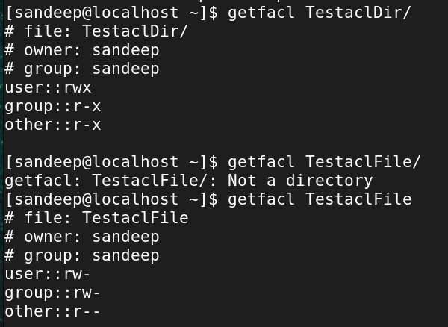

1. Change the group of the file and dir to sports. (assuming you have a group named sports)

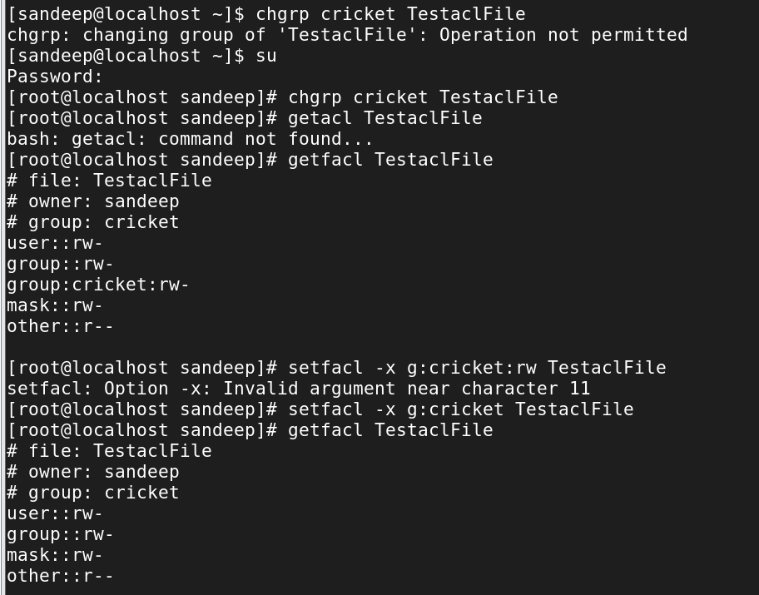

1. Add a user – Sachin to sports. (usermod -aG cmd)

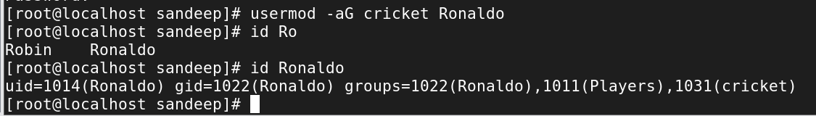

1. Now use setfacl cmd on TestaclDir to give permission -rwx (7) for user Laura
2. Use setfacl -m u:username:permission file/dirname

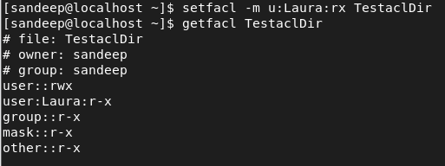

1. Use setfacl --no-mask -m u:username:permission file/dirname ( the grp permissions will not change)

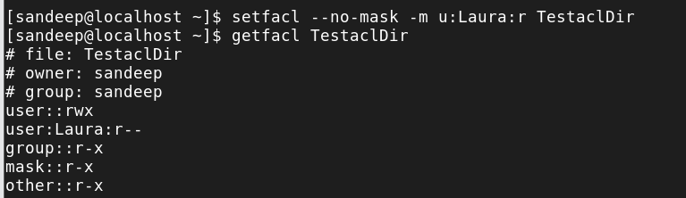

e. Setfacl on TestaclDir for group -Chess with permissions -rx (7)

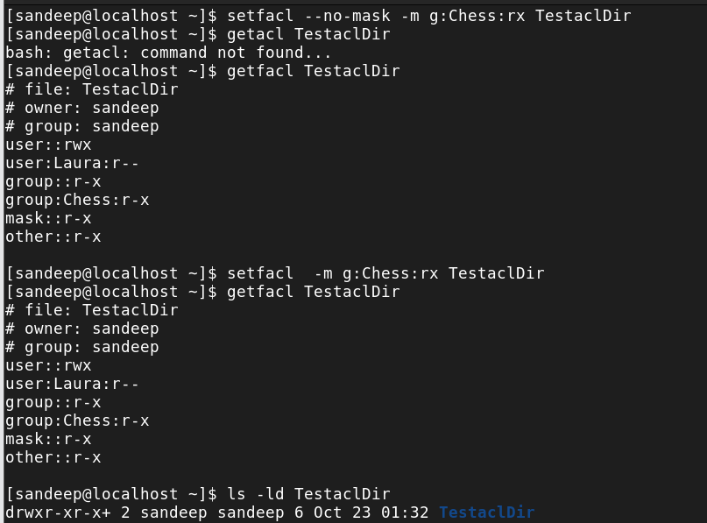

g. Access the dir as Robin and test the permissions before and after setting the acls

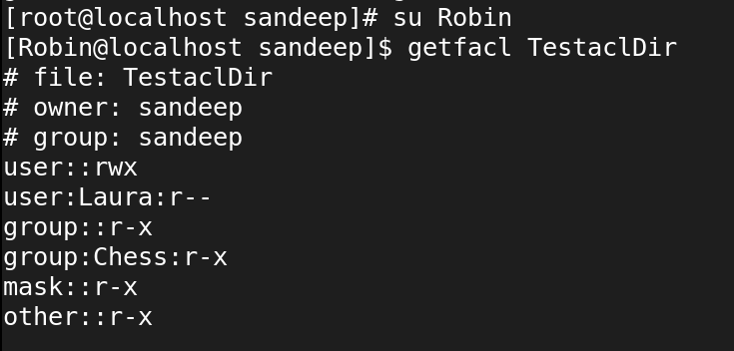

1. Repeat 7. For file TestaclFile

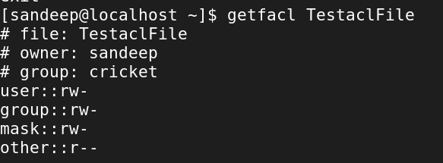

1. Use setfacl -m u:username:permission file

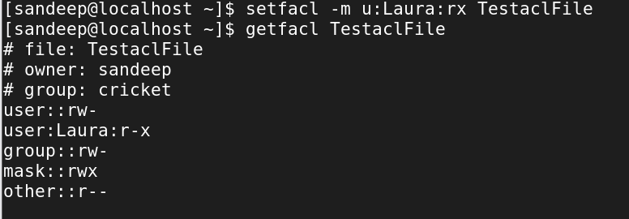

1. Use setfacl --no-mask -m u:username:permission file/dirname ( the grp permissions will not change)

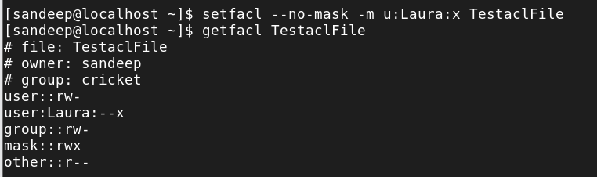

1. Observe a + sign

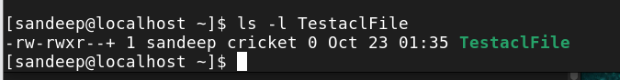

1. Setfacl on TestaclFile for group -Chess with permissions -r (7)

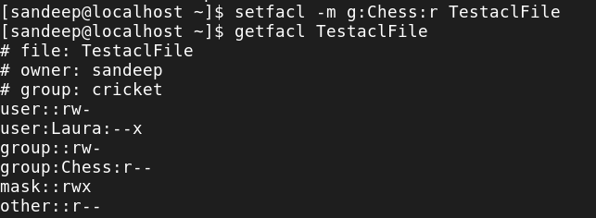

1. Remove the acl s using setfacl -x u/g :user/grp file/dirname and chk with getfacl cmd

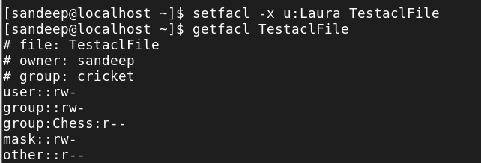

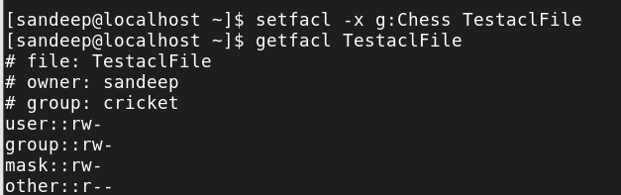

1. Remove all acls using setfacl -b file/dirname

